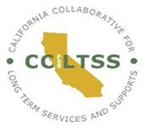

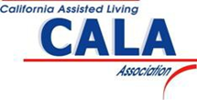

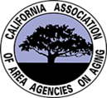

California Collaborative for Long Term Services and Supports
Laurel Mildred
laurel.mildred@mildredconsulting.com
916-862-4903

AARP California
Nina Weiler-Harwell
nweiler@aarp.org
916-556-3027

California Advocacy Network for Aging Latinos
Cecilia Zamora
latinocoun@aol.com

California Assisted Living Association
Heather Harrison
hsh@caassistedliving.org
916-448-1900

California Association for Adult Day Services
Lydia Missaelides
lydia@caads.org
916-552-7400

California Association of Area Agencies on Aging
Derrell Kelch
aging@c4a.info
916-443-2800

California Association of Caregiver Resource Centers
Vicki Ferrell
VFarrell@csuchico.edu

California Association of Health Facilities
Karen Widerynski
kwiderynski@cahf.org
562-253-1445

California Association of Health Plans
Athena Chapman
achapman@calhealthplans.org
916-552-2910

California Medical Association
Yvonne Choong
ychoong@cmanet.org

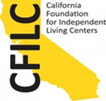

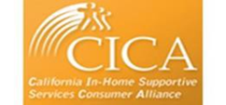

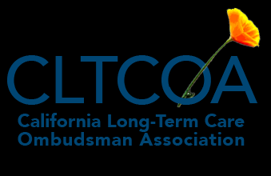
California Association of Public Authorities
Karen Keeslar
keeslar@sbcglobal.net
916-813-5454

California Commission on Aging
Carol Sewell
csewell@ccoa.ca.gov
916-419-7591

California Council of the Alzheimer’s Association
Susan DeMarois
sdemarois@alz.org
916-447-2731

California Council of the Blind
Jeff Thom
jsthom@comcast.net

California Elder Justice Coalition
Terri Deits
terrideits@gmail.com
707-815-2500

California Foundation for Independent Living Centers
Henry Contreras
henry@cfilc.org
916-761-5979

California Health Advocates
Tatiana Fassieux
tfassieux@calhealthadvocates.org
530-521-7502

California Hospital Association
Pat Blaisdell
pblaisdell@calhospital.org
916-552-7553

California In-Home Supportive Services Consumer Alliance
Janie Whiteford
janiewhiteford@yahoo.com
408-366-6034

California Long-Term Care Ombudsman Association
Leza Coleman
lcoleman@cltcoa.org
916-375-3313

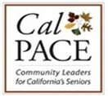

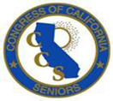

Justice in Aging
Amber Christ
achrist@justiceinaging.org
213-674-2901

California State Independent Living Council
Cheryl Kasai
cheryl@calsilc.org
916-445-0142

Californians for Disability Rights
Randy Hicks
Rhfactor_98@yahoo.com
916-803-0702

CalPace
Peter Hansel
phansel@calpace.org
916-469-3368

Coalition for Compassionate Care of California

Congress of California Seniors
Gary Passmore
garyp@seniors.org
916-442-4474

Disability Rights California
Curtis Child
Curtis.child@disabilityrightsca.org

Family Caregiver Alliance
Kathleen Kelly
kkelly@caregiver.org
415-434-3388

Harris Family Center for Disability and Health Policy (HFCDHP)
June Kailes
jik@pacbell.net

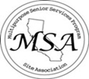

LeadingAge California
Jedd Hampton
jhampton@leadingageca.org
916-469-3366

Lifelong Medical Care
Marty Lynch
mlynch@lifelongmedical.org
510-981-4123

Multipurpose Senior Services Program Site Association
Janet Heath
mssp.association@gmail.com
916-397-1509

SEIU – California
Tiffany Whiten
twhiten@seiucal.org
916-288-1462

The ARC California

UDW/AFSCME Local 3930
Kristina Bas Hamilton
kbas@udw.org
916-554-0931

